WARLORD Game Rules v2

# General

## The Vibe

WARLORD is a game in the family of board games that includes Chess and Checkers, where tokens/pieces move on a fixed grid, capturing/taking opponents pieces in order to conquer the opponents’ force in some fashion.

## Differences from Similar Games

WARLORD is most similar to checkers as the goal is take (almost) all of an opponents pieces and all pieces move the same way.

However, it is different than checkers in a few ways:

* Special Piece – this is explained further in the “Piece Types” section, but there is a “Warlord” piece which cannot be taken. The goal of the game is to take every piece EXCEPT the Warlord.
* Movement – In WARLORD, all pieces move akin to the King in Chess – that is, all pieces may move to any adjacent space.
* RPS – this is also explained further in “Piece Types:” certain pieces may take only certain other types of pieces. This forms the core of the WARLORD game play.
* Player Count – you can play WARLORD with 2, 3, 4, 5, or 6 players, though each mode requires a different game board.

# Piece Types

## WARLORD

WARLORD is a game which simulates a battle between two small armies led by the first piece, a Warlord.

The Warlord is uncontested in combat, a master of battle. As such, the piece that represents him cannot be taken and may take on any other piece.

## Battalions

The other pieces form a triangular taking relationship akin to rock-paper-scissors.

There are Infantry, foot soldiers carrying pikes and side-swords, (light) Cavalry, unarmored horse-riders, and Artillery, skilled archers.

The pike-men of the Infantry band together and are able to defeat the Cavalry. The Cavalry stomp, disrupt, and destroy the bowmen of the Artillery. The Artillery dominate the Infantry, to heavy and grouped up to avoid volleys of arrows.

In other words, Infantry (Spear Pieces) beat Cavalry (Horse Pieces) which beat Artillery (Bow Pieces) which beat Infantry. Rock-Paper-Scissors.

## Collection

Each side starts the game with 1 Warlord, 3 Infantry, 3 Cavalry, and 3 Artillery.

## Piece Images

### Warlord – Crown

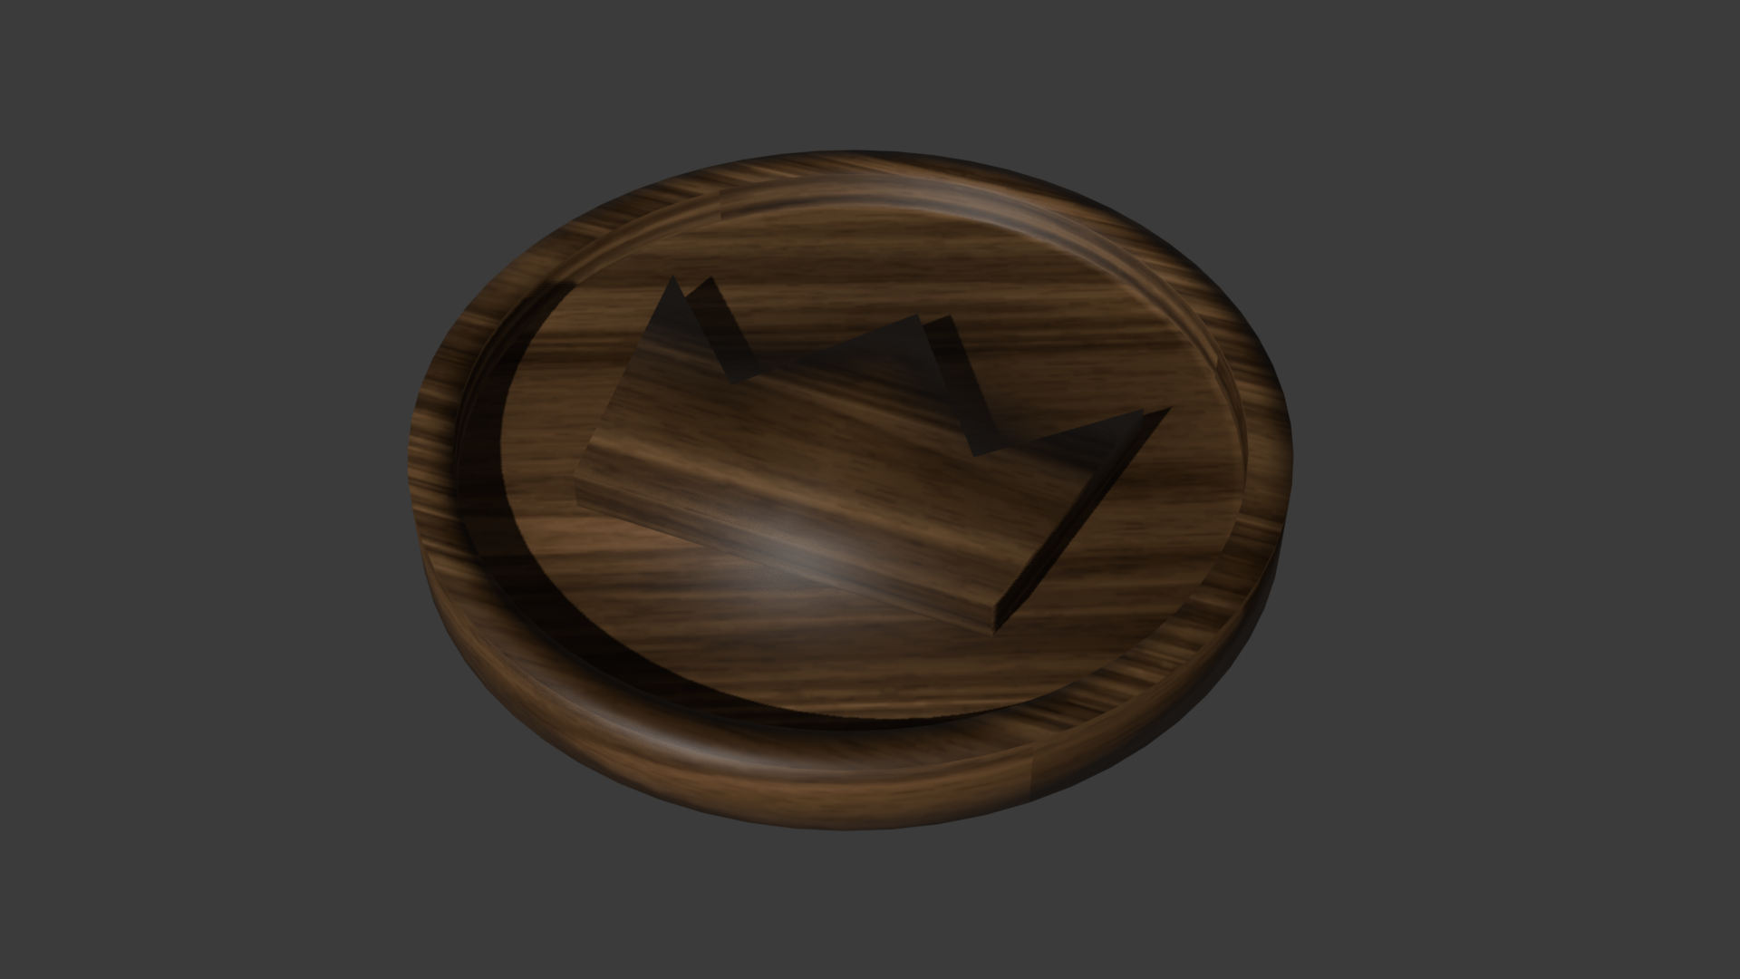

### Infantry – Double Spears

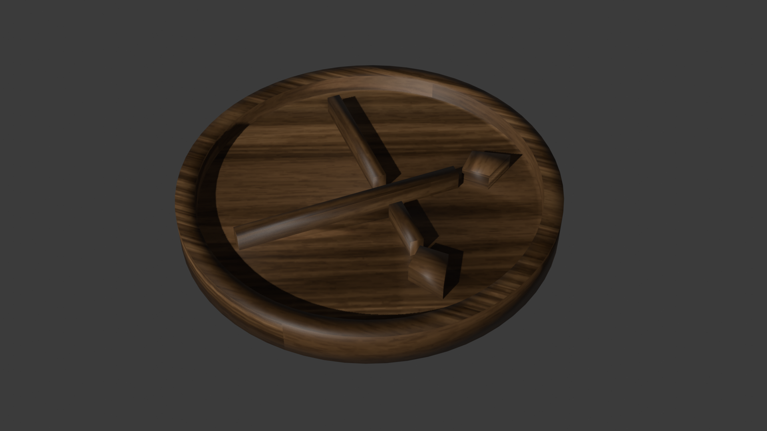

### Cavalry – Horse

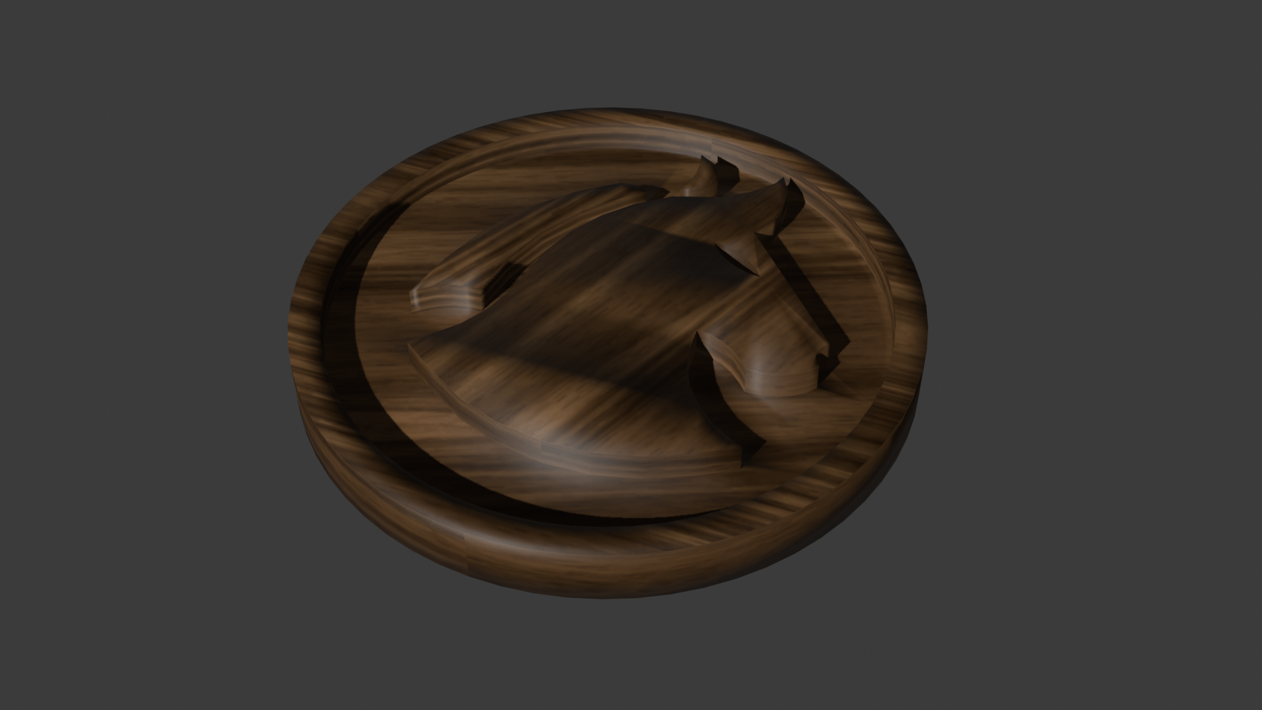

### Artillery – Bow

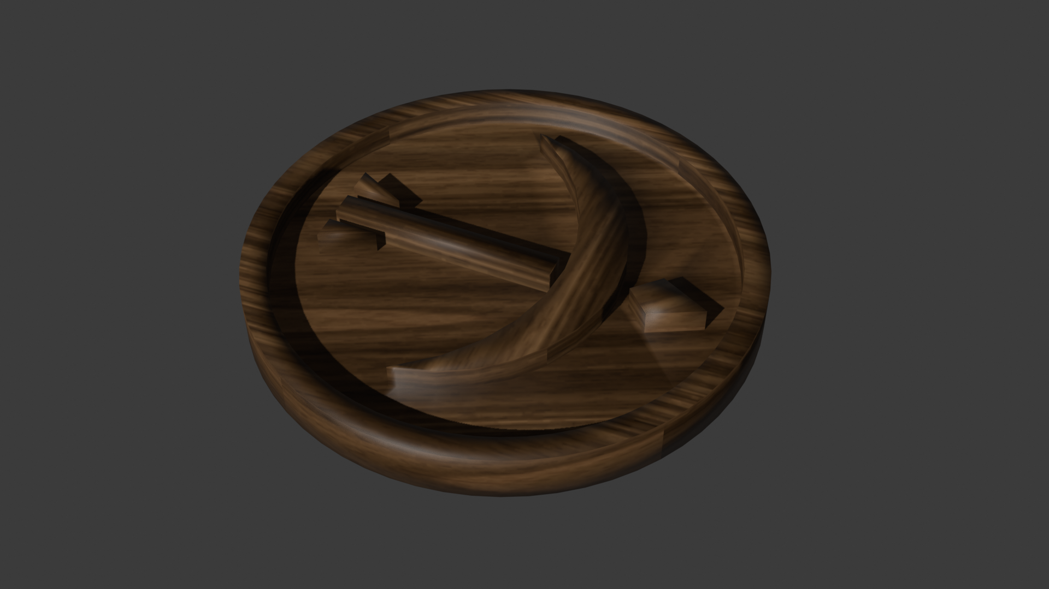

# Gameplay

## Setup

The game may be played with 2-6 players. Each type of play requires a different game-board. Regardless of board, however, there is a region for each player to start in, a 3 by 9 square grid. Each player may place their troops (again, 1 Warlord, 3 Infantry, 3 Cavalry, and 3 Artillery) anywhere they’d like within this grid.

Each player rolls a dice. The player with the highest dice goes first and turns proceed clockwise. In the event that multiple players roll the same number, those players continue to roll until there is only one left.

## Turn

On each turn, players have a decision:

1. They may move their powerful WARLORD who can take all and not be taken
2. They move one piece for each type of soldier pieces (Cavalry, Infantry, Artillery), i.e. 3 moves.

All pieces may move to any adjacent space, unless another piece is already there.

If a piece exists where you want to move, you may only move there, taking that piece in the process, if the piece relationship conforms to the rock-paper-scissors system explained in the “Piece Types” section. That is, an Infantry may take a Calvary piece and move to its position or a Calvary to an Artillery or an Artillery to an Infantry, but never when the piece types match nor in the reverse direction, i.e. Cavalry taking an Infantry.

The exception being that the Warlord piece may be moved anywhere and take any piece.

## End

The game ends when one player has conquered the board, meaning there are none of their opponent’s/opponents’ pieces left in play.

In multiplayer games, if all your pieces are removed (and the game is still going), you are defeated and have been conquered and subjugated to whoever took your last piece. Remove your Warlord from the board, and support the player who conquered you as they try to conquer the rest of the board.

# Board Definitions

The following images define how to make a board for WARLORD given the number of players.

## 2 Player

Very standard. Similar to Chess/Checkers, but a different size.

Each player gets their 3x9 starting area. Between is a 3x9 play area that players may not start in.

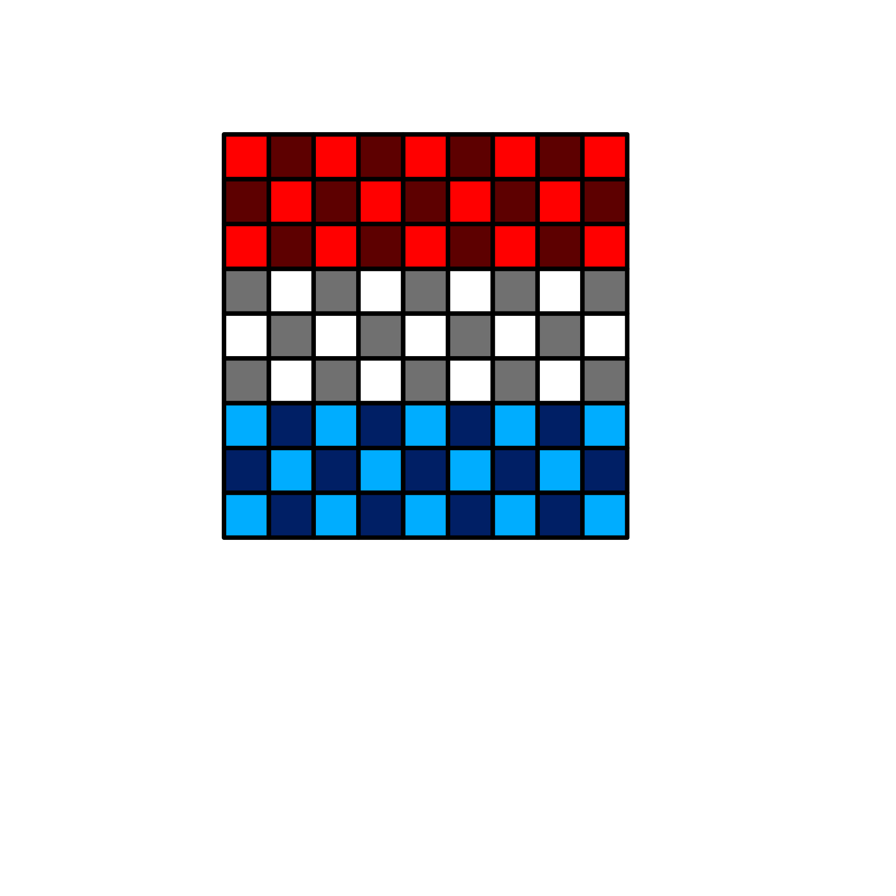

## 3 Player

The main play area is made up of triangular tiles in a 9x9x9 equilateral triangle.

Each player gets a 3x9 starting area which extends out from each of the three sides.

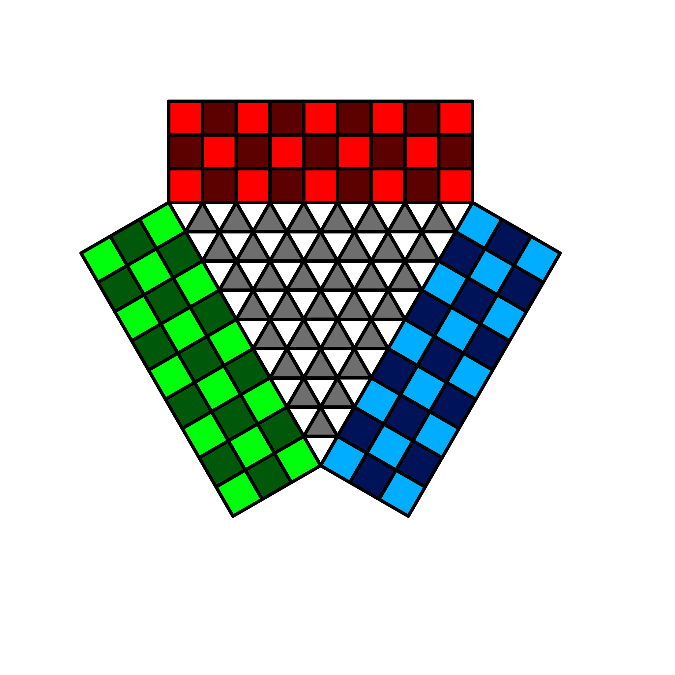

## 4 Player

Essentially converting the 2 player board into the battlefield and adding 4 starting areas to each side.

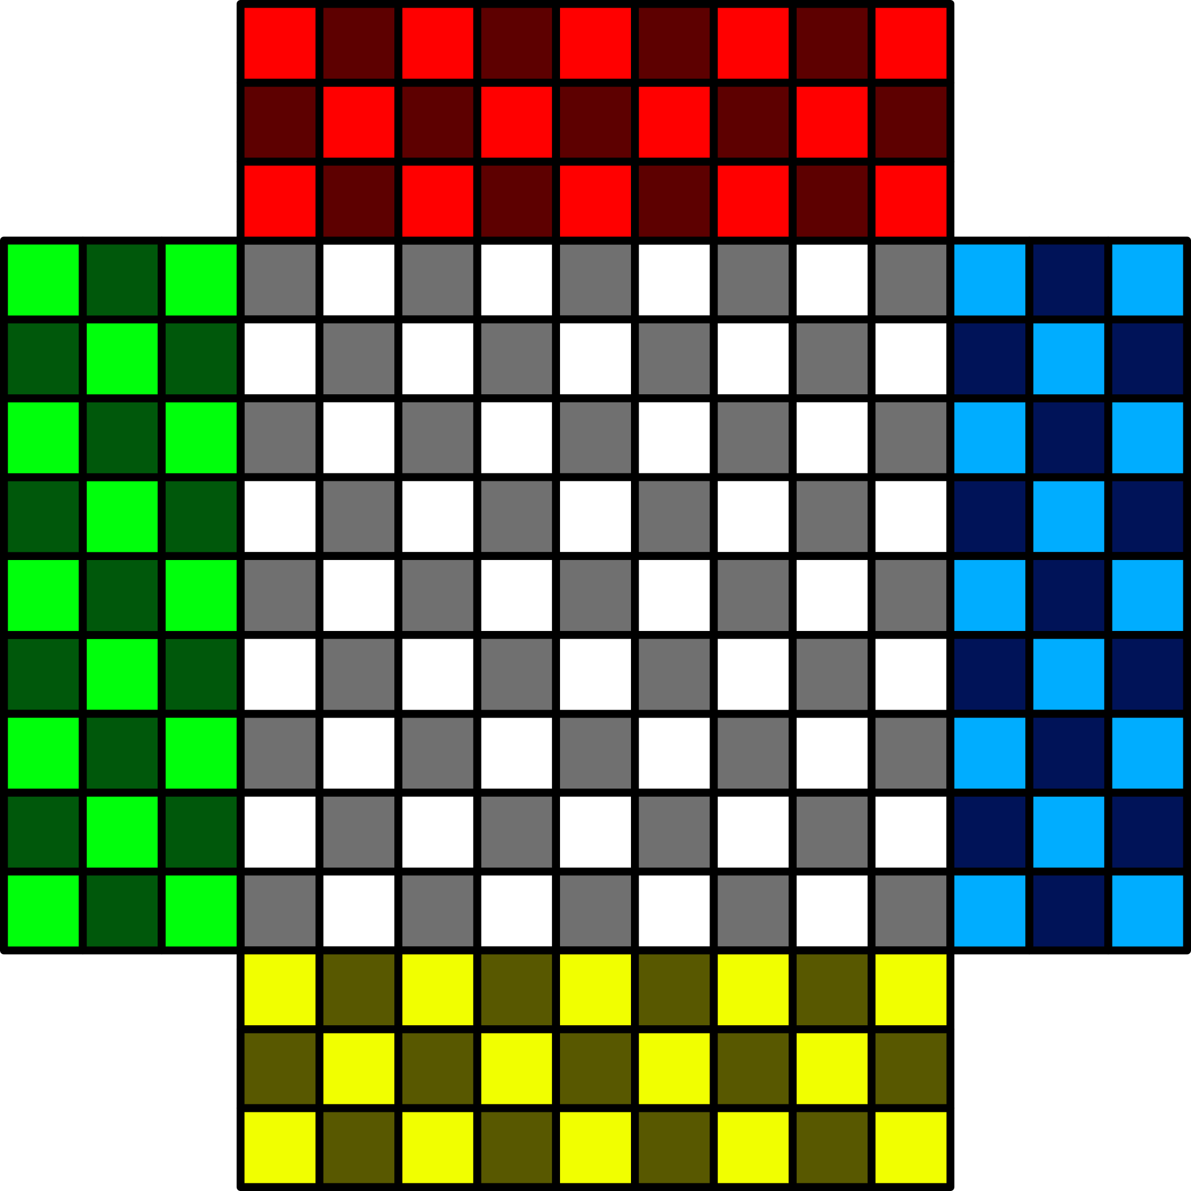

## 5 Player

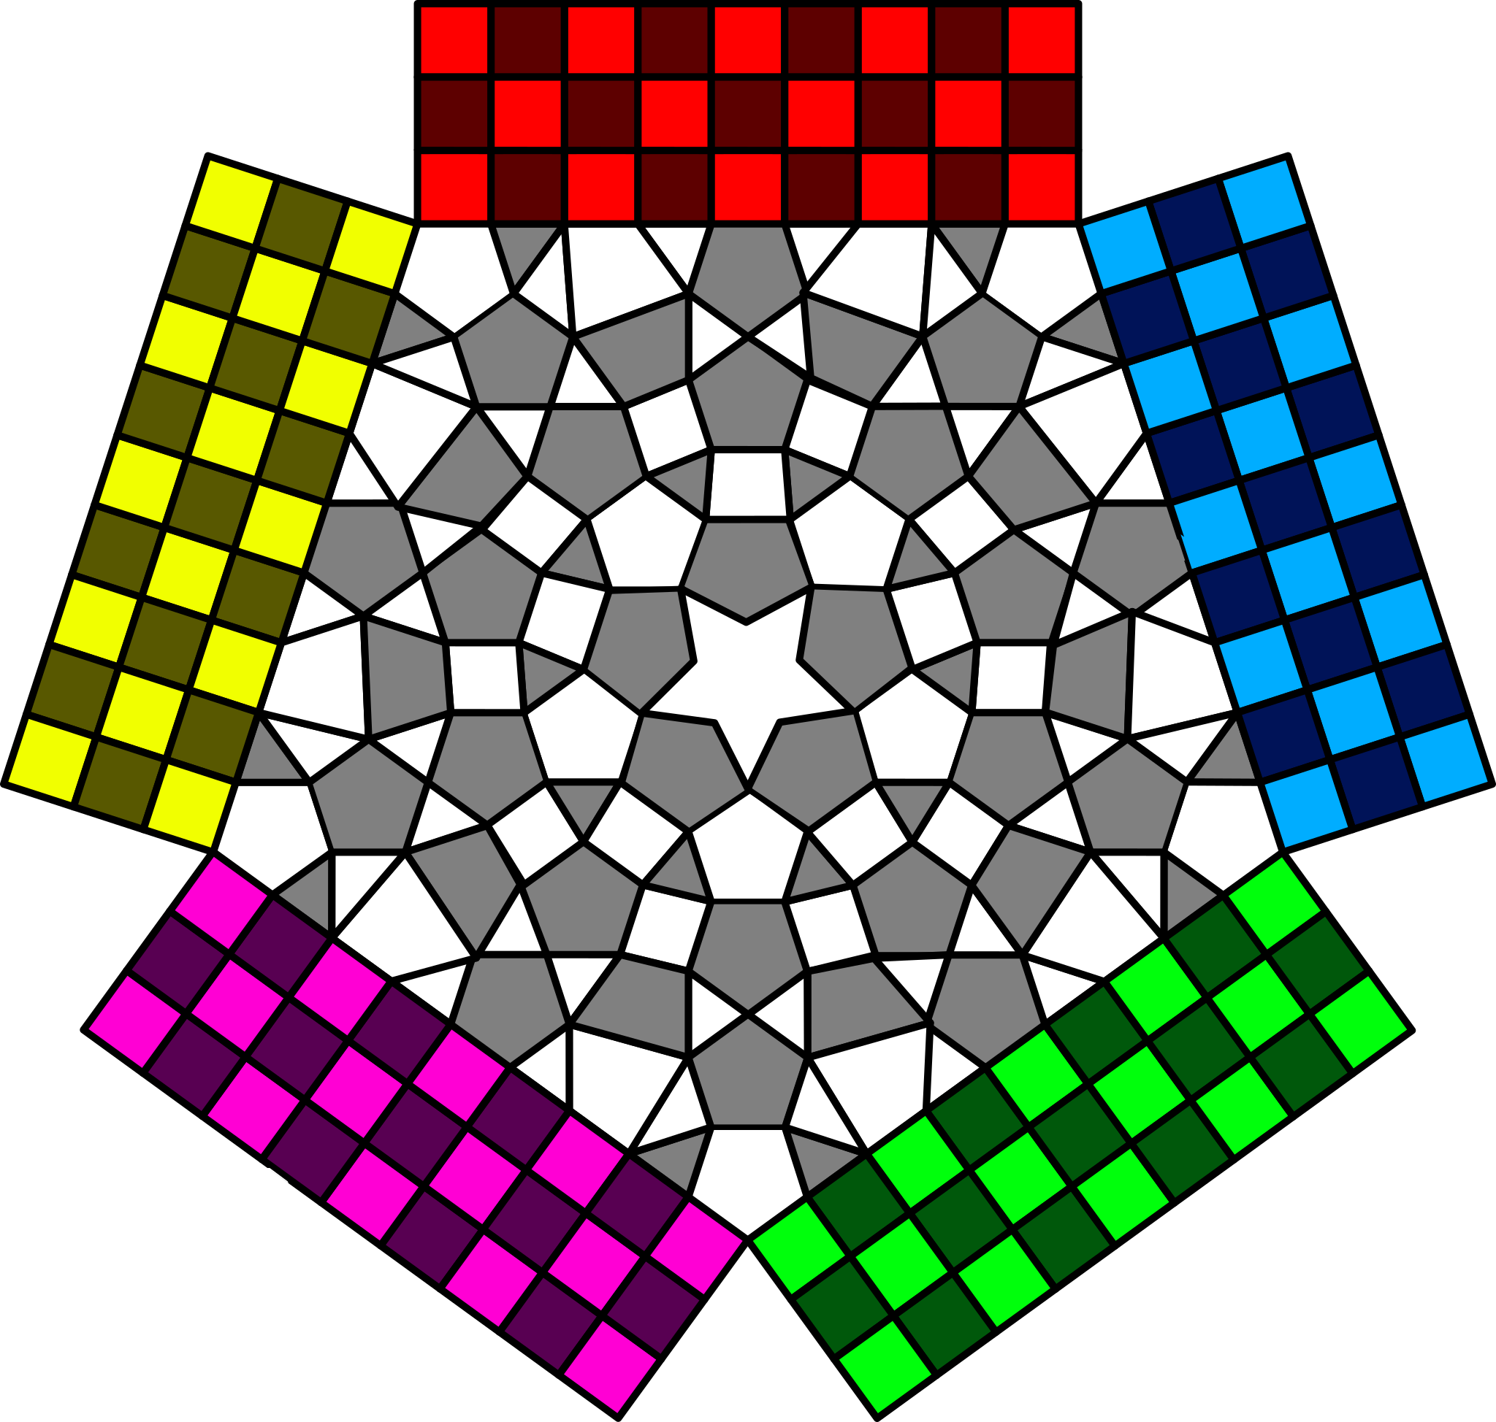

## 6 Player

